Transition – what’s after high school sports?
Presented by Kinesiology Class – Sport and Community Service and UWO Women’s Rugby team
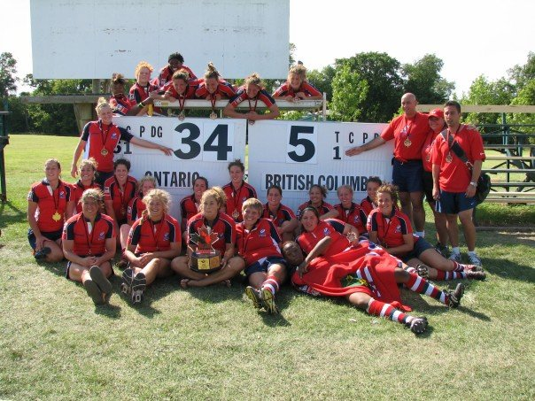
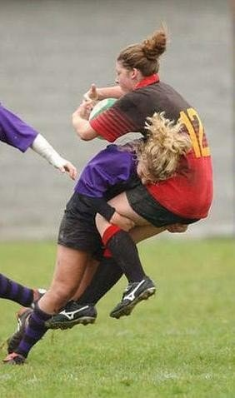

Featured Speakers
Melissa Baer
Members of UWO women’s Rugby team
Natascha Wesch
Intramural Athletes

Who: Female Athletes in grades 11 and 12 (rugby players)
When: Saturday April 8th 12pm- 2pm
Where: Western campus, Thames Hall 3102 /TRAC
What: Information about what athletes want to know and need to know to make the move to Varsity, Information for students who want to keep active after high school. The day will feature a variety of very useful information it will also feature an interactive skills session with new drills you can take back to your teams, and an opportunity to ask current varsity athletes questions and hear their experiences!

REGISTRATION
Contact Melissa Baer
Mbaer2@uwo.ca
519 642 1366
Include the following information:

- Name
- High school
- Numbers attending

